**Lab 2: OS Installation & Practice on Basic Networking Commands**

**Theory**

**Linux**

Linux is an open-source, Unix-like operating system kernel that serves as the foundation for a wide range of operating systems, collectively known as Linux distributions (e.g., Ubuntu, Fedora, Debian). It is renowned for its stability, security, and flexibility, making it a popular choice for servers, desktops, and embedded systems. It’s open-source nature allows users to freely modify and distribute the software.



Fig: Linux

**VirtualBox**

VirtualBox is an open-source virtualization software developed by Oracle, allowing users to run multiple operating systems simultaneously on a single physical machine. It supports a wide range of guest OS types and is available on various host platforms, making it a versatile tool for testing, development, and learning environments.

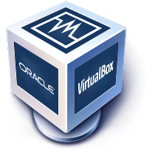

Fig: VirtualBox

**VMware**

VMware is a leading provider of virtualization solutions, offering products like VMware Workstation and VMware vSphere that enable users to create and manage virtual machines on a single physical host. Known for its robust performance and enterprise-grade features, VMware is widely used in professional IT environments for server consolidation, application testing, and cloud computing.

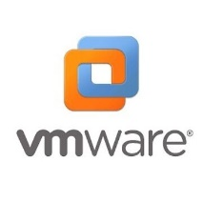

Fig: VMware

**Installing the Virtual Box**

Oracle VM Virtual Box is cross-platform virtualization software that allows users to extend their existing computer to run multiple operating systems including Microsoft Windows, Mac OS X, Linux, and Oracle Solaris, at the same time.

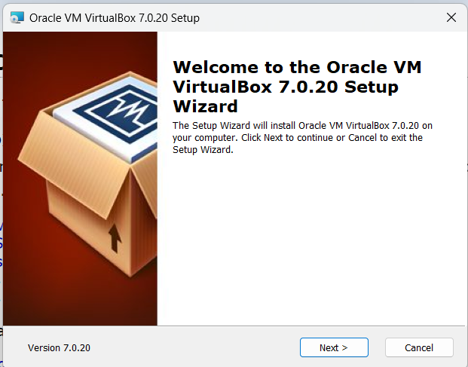

Fig: VirtualBox Setup

Here Click on Next and proceed.

Once Virtual Box is installed then we can create, add or import new VMs using toolbar buttons.

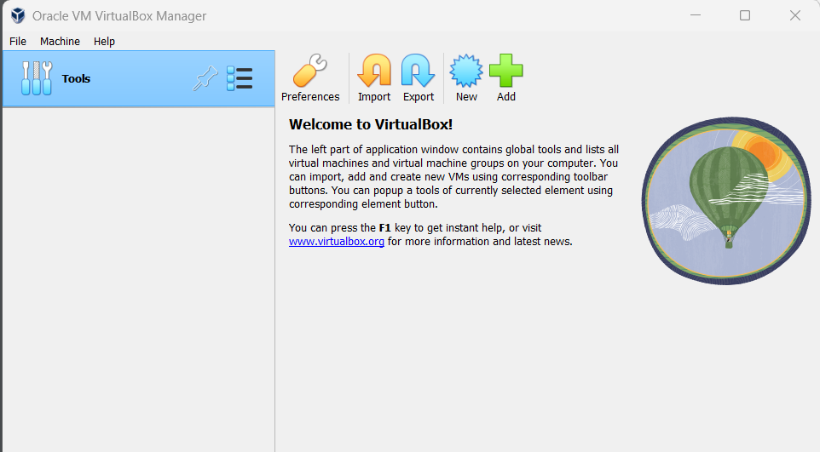

Fig: VirtualBox Manager

**Installing Linux (Ubuntu) Desktop OS**

**Step 1:** Click New on Virtual Machine toolbar and add details about the new VM and required OS.

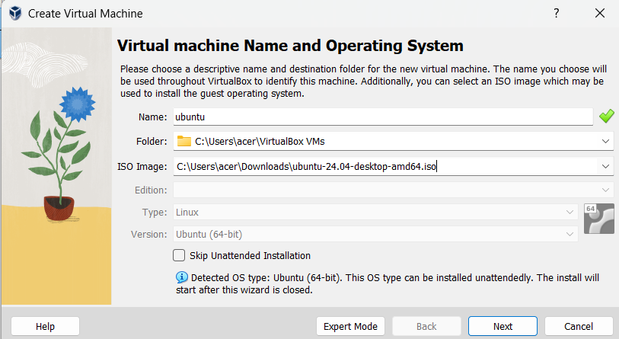

Fig: Virtual Machine Toolbar

**Step 2:** Select the Base Memory and Processors to be allocated to the Virtual Machine.

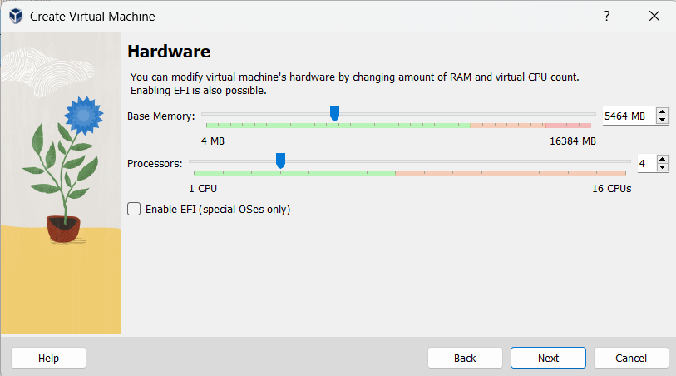

Fig: Base Memory and Processor

**Step 3:** Select the size of memory to be allocated for Virtual Hard Disk.

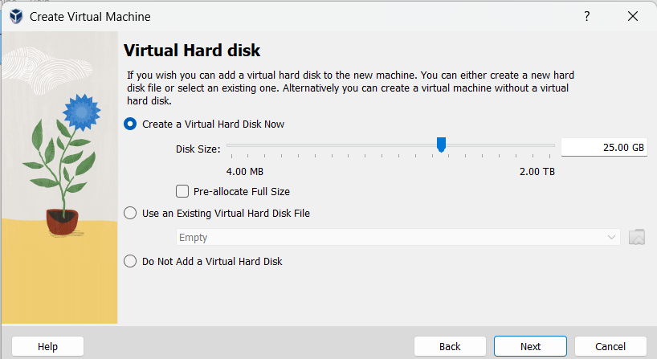

Fig: Allocation of Memory for Virtual Hard Disk

**Step 4:** This is the interface for the newly created Virtual Machine for Ubuntu Desktop OS. Select Server and Press on **Start** to run the Virtual Machine.

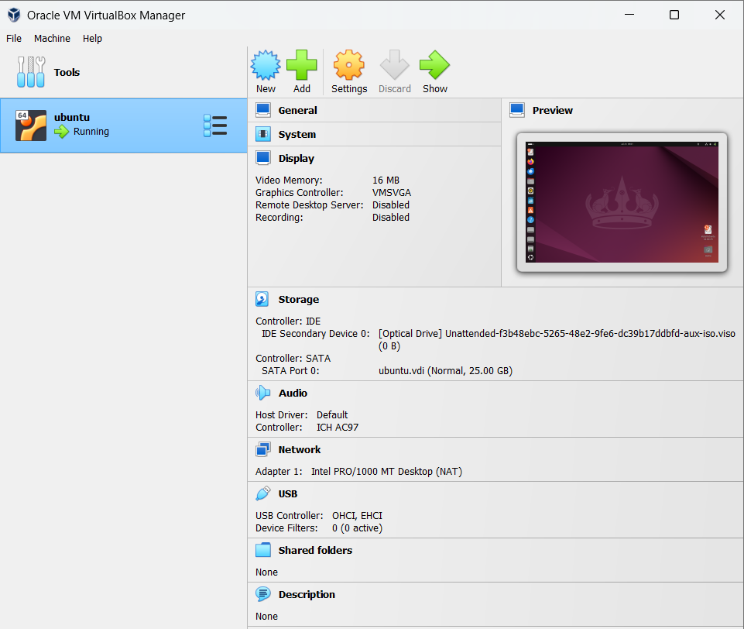

Fig: Ubuntu VM Startup

**Step 5:** Select the preferred language and click next.

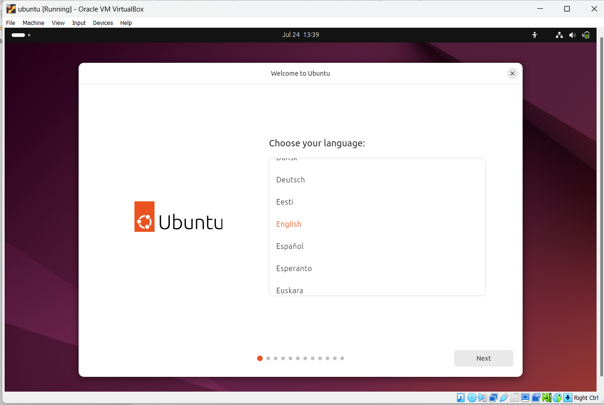

Fig: Selection of language

**Step 6:** Select the preferred keyboard layout and its variant, click on next once finished.

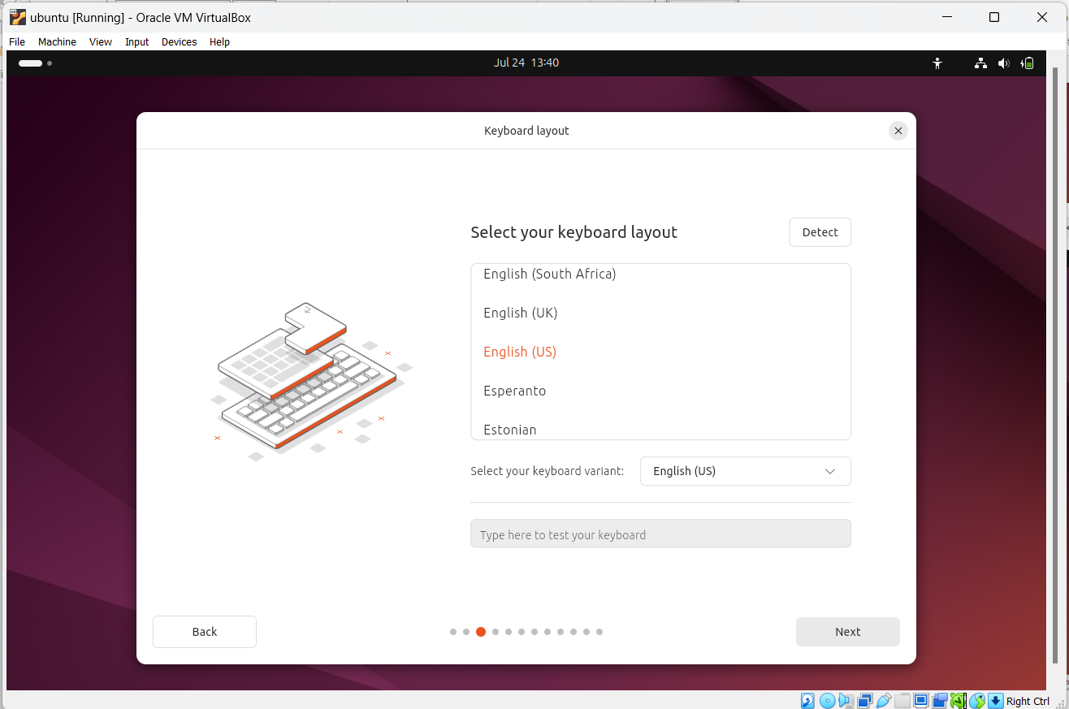

Fig: Selection of keyboard layout

**Step 7:** Press on install Ubuntu server and click next.

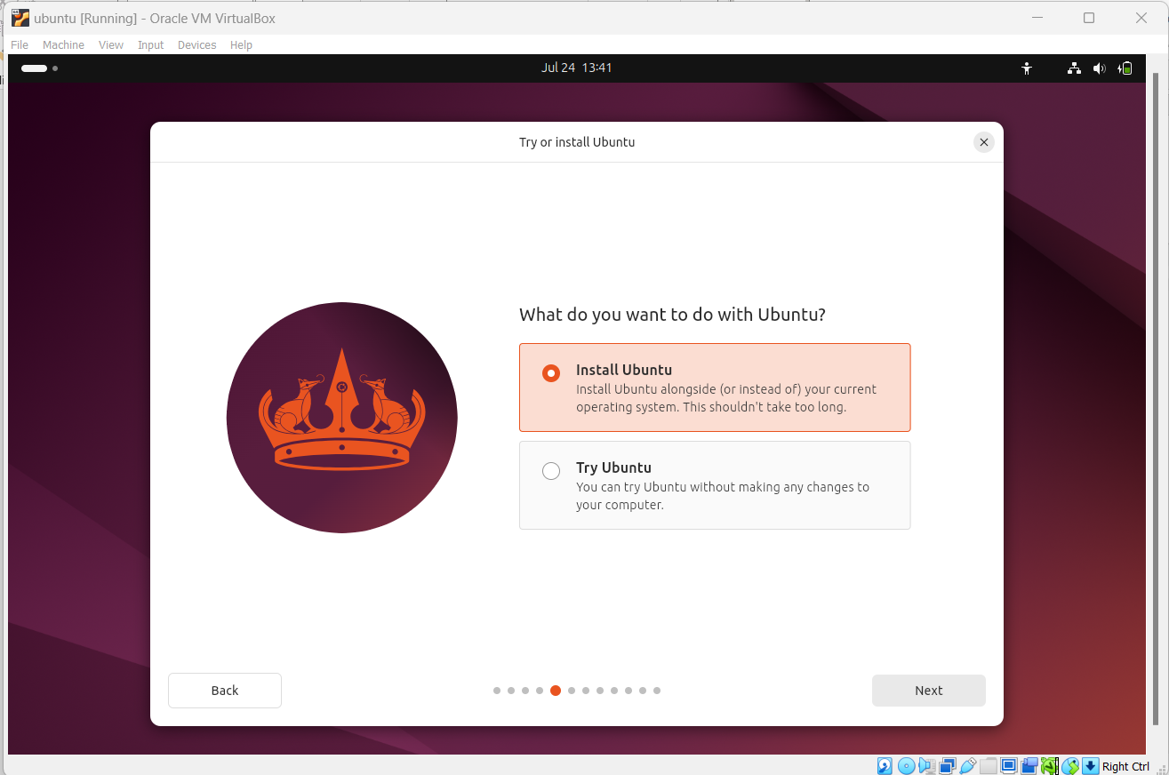

Fig: Ubuntu Installation

**Step 8:** We will be asked to choose the installation type. Once selected we can click next.

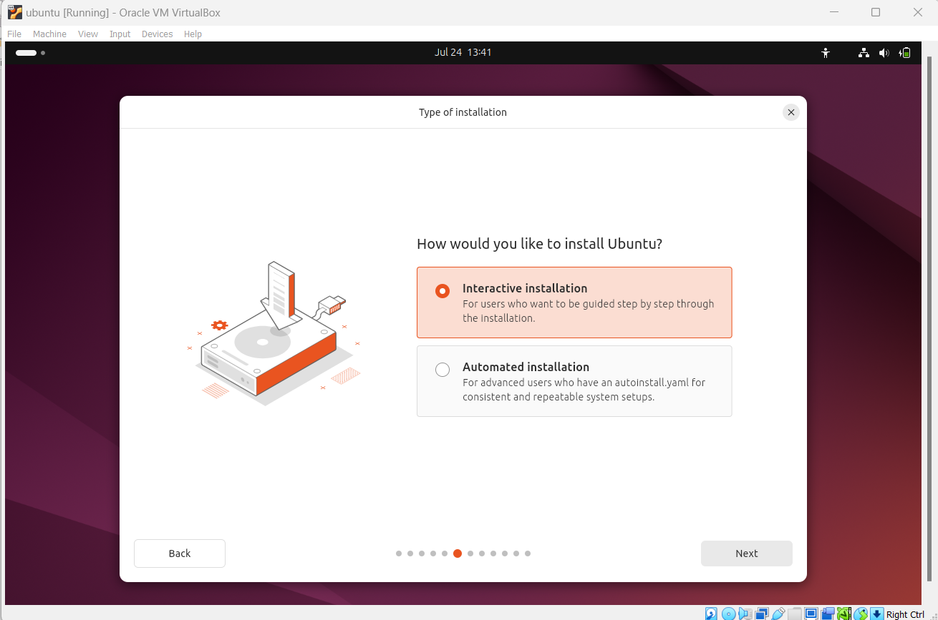

Fig: Selection of Installation type

**Step 9:** Wewill be ask to choose apps to install with start. Once selected we can click on next.

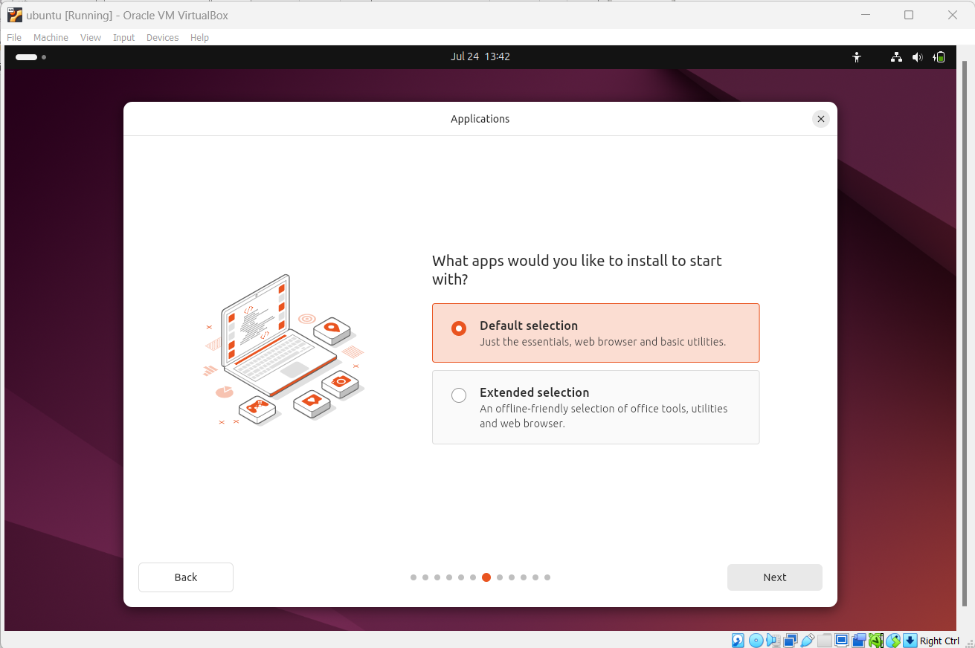

Fig: Choosing Other Software

**Step 10:** It will prompt us to choose updates for latest version. We can choose or skip the options and click on next.

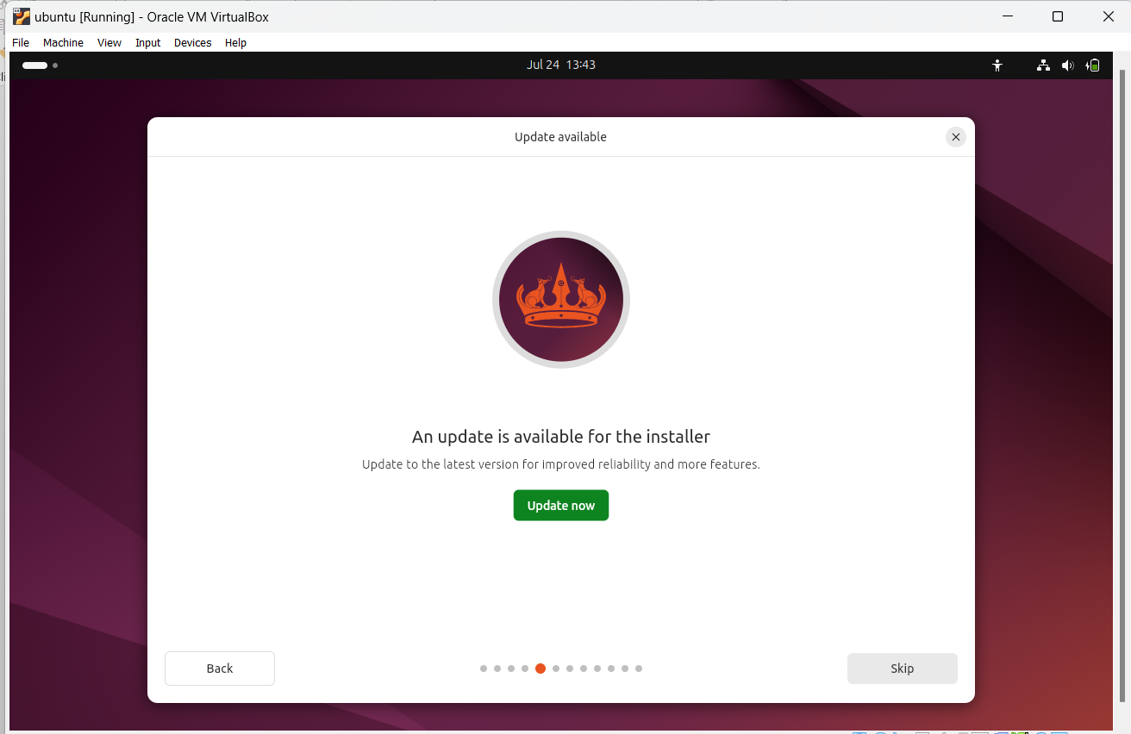

Fig: Update of latest version

**Step 11:** Wewill be ask to install recommended proprietary software. Once selected we can click on next.

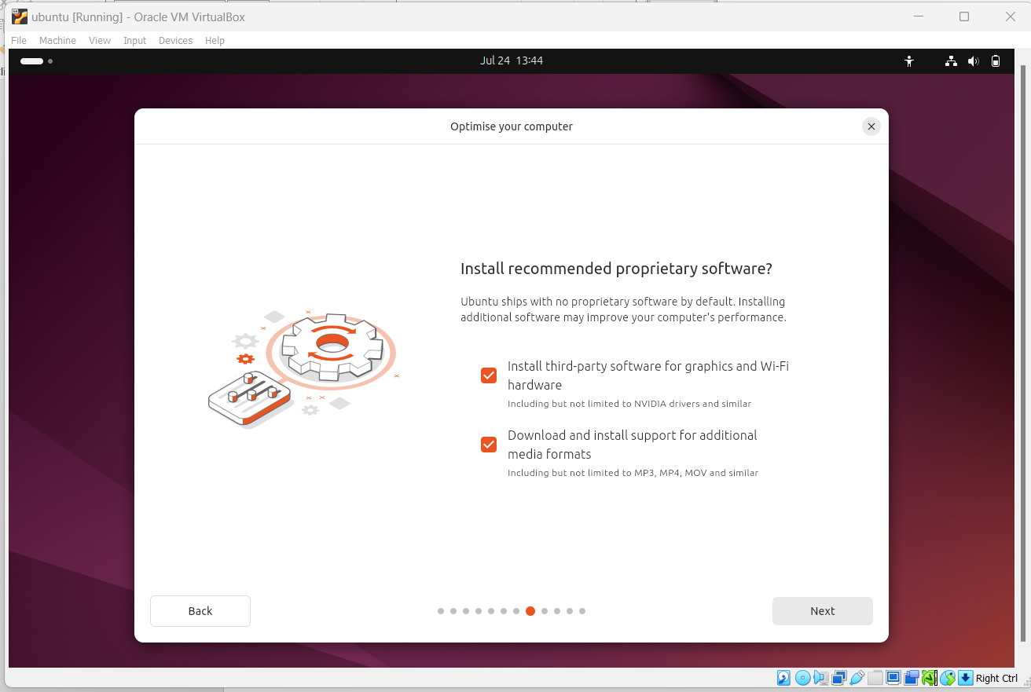

Fig: Installation of recommended proprietary software

**Step 12:** It will prompts ‘How do you want to install Ubuntu’. .Once selected we can click

on next.

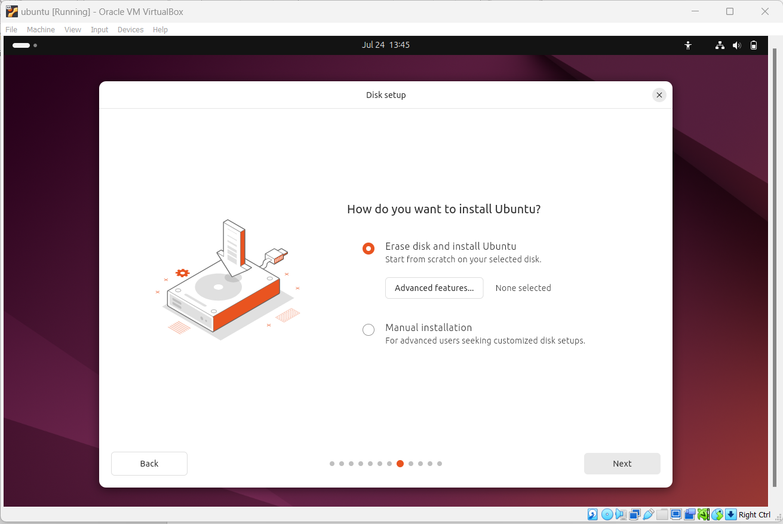

Fig: Choose installation type

**Step 13:** Setup the profile for the user that includes username, password, computer’s name etc. Once finished click on next.

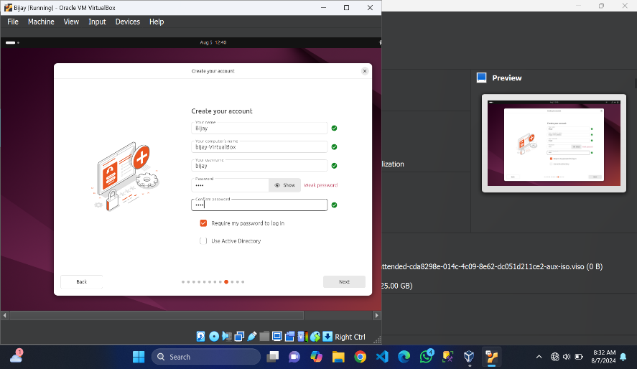

Fig: User profile setup

**Step 14:** Select the location and press next.

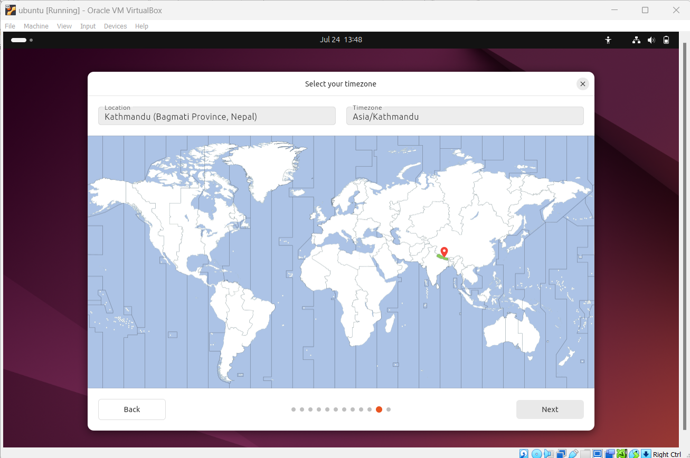

Fig: Selection of location

**Step 15:** Review all setup choices and click on install.

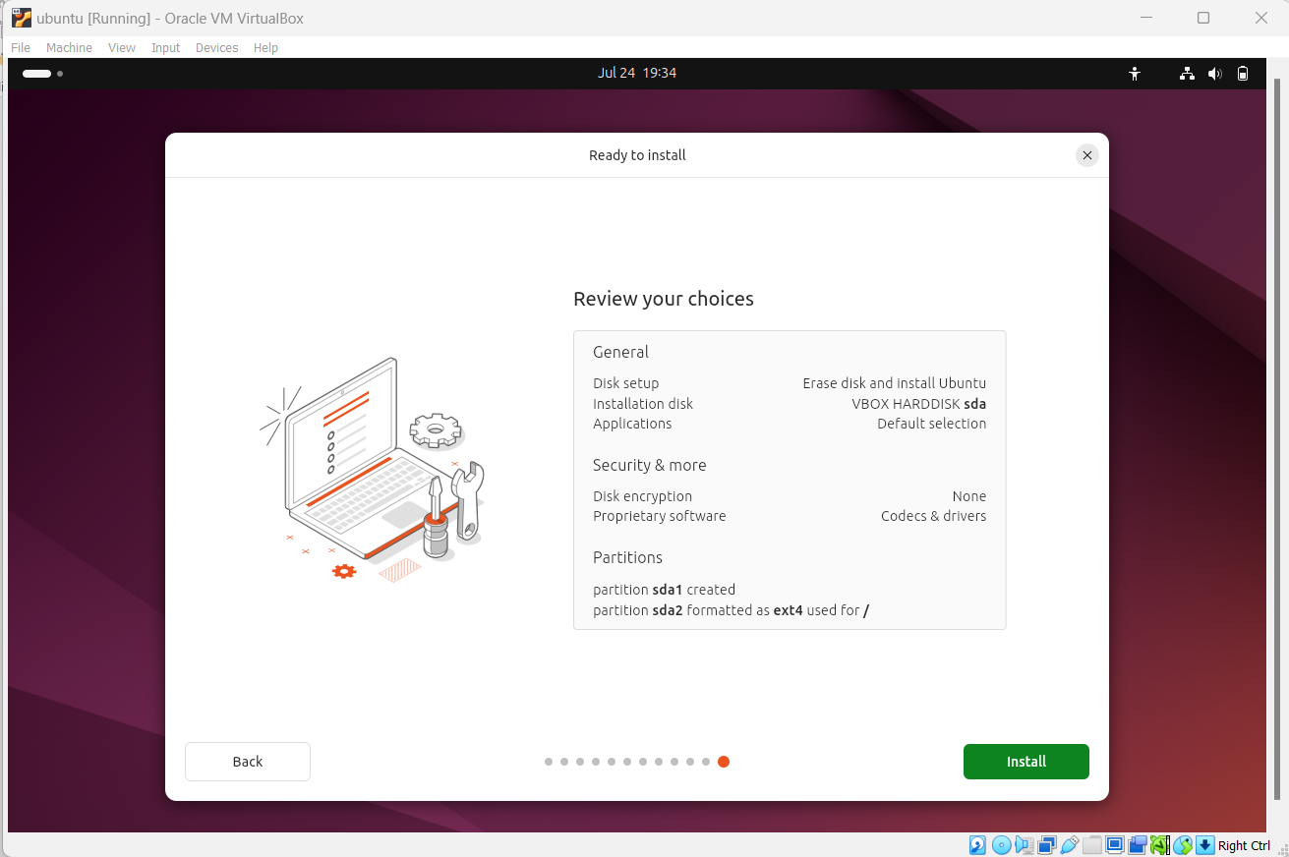

Fig: Review Choices

**Step 16:** Upon the completion of the installation process, the window on the right will prompt Restart now. Click on restart now for restarting Ubuntu server.

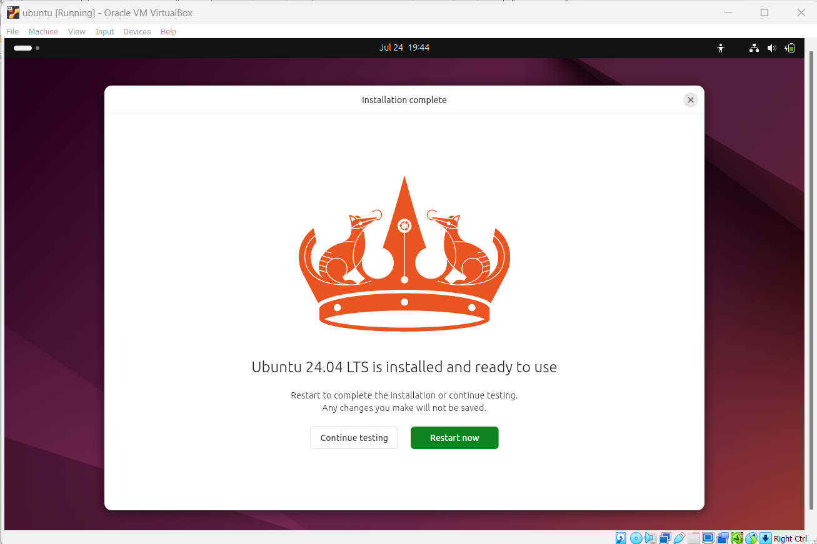

Fig: Completion of installation and ready to restart

**Step 17:** Now enter the Login details on the screen and press Enter to login into the system.

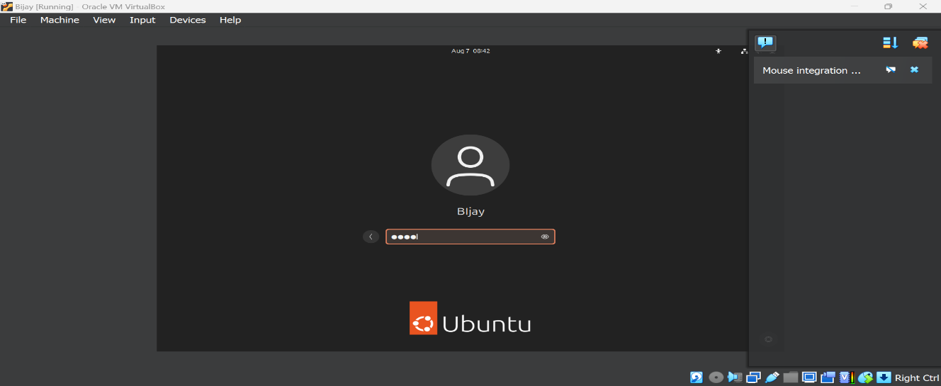

Fig: Login Process

**Step 18:** Now our system is ready and Ubuntu is installed completely.

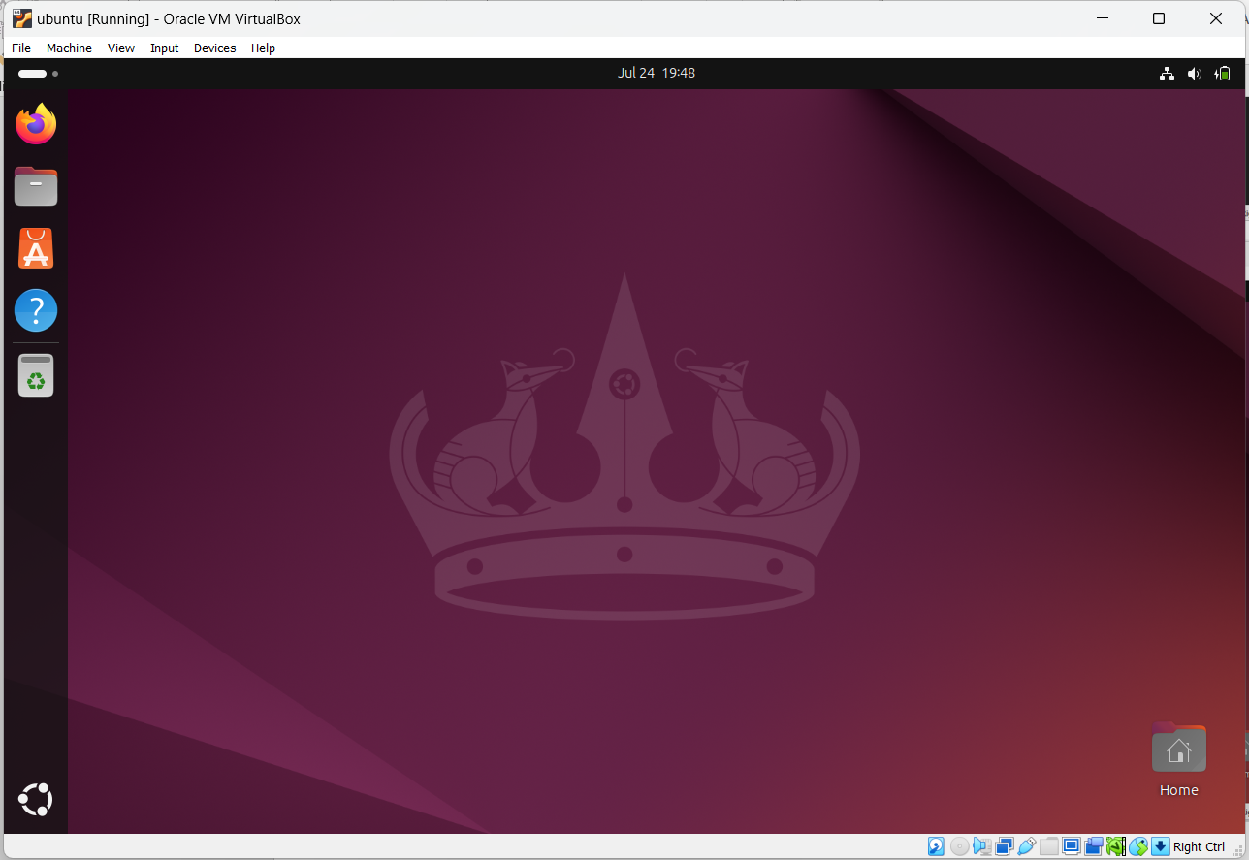

Fig: Ubuntu Home Screen

**Basic Networking Commands**

**1.PING**

Ping (Packet Internet Groper) is a command-line utility used to test network connectivity between two hosts by sending ICMP echo request packets and waiting for ICMP echo reply packets.

**Syntax:** ping [options] hostname or IP address

**Uses:** Used for checking whether any network is present and if a host is attainable.

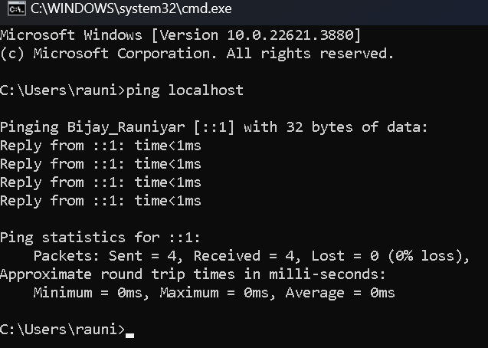

Fig: Packet Internet Groper (PING)

**2.IPCONFIG**

Ipconfigstands for "Internet Protocol Configuration"*.* It is a program of console application of a few computer OSes that shows every current value of TCP/IP network configuration and refreshes DNS and DHCP settings.

**Syntax:** ipconfig

**Uses:** Used to view and manage network configuration settings, renew DHC Pleases, flush DNS cache, and configure network interfaces.

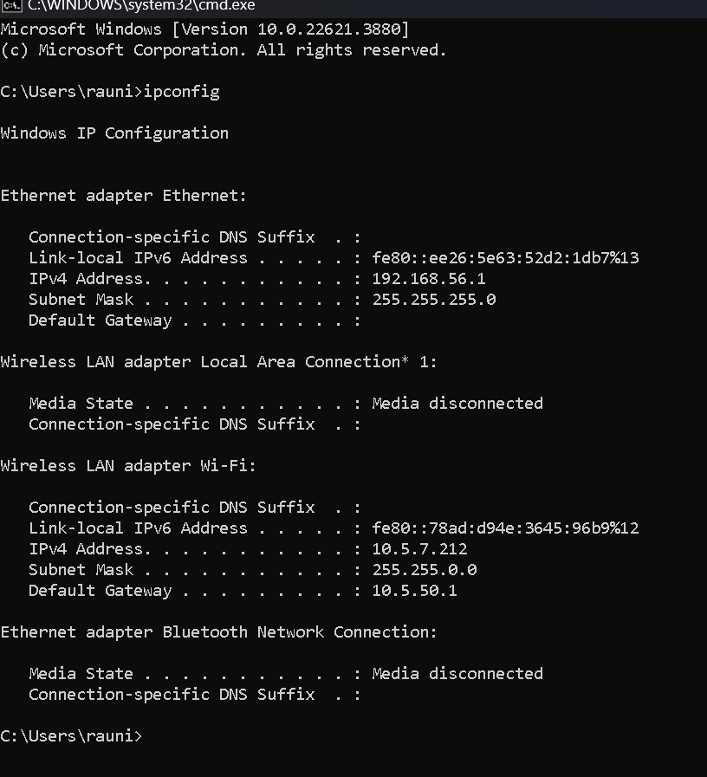

Fig: IPCONFIG

**3.GETMAC**

MAC address is the physical address, which uniquely identifies each device on a given network. To make communication between two networked devices, we need two addresses: **IP address and MAC address.** It is assigned to the NIC (Network Interface card) of each device that can be connected to the internet.

**Syntax:-** getmac

**Uses:** Commonly used in troubleshooting network issues and for network security purposes.

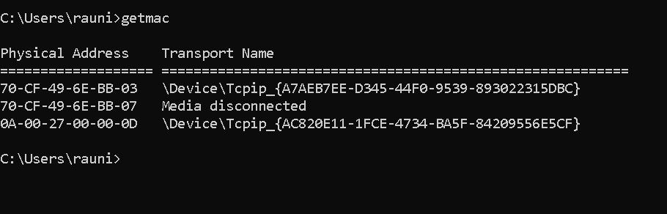

Fig: GETMAC

**4.HOSTNAME**

Hostname is a command-line utility used to display or set the name of the computer or device within a network. It can be accessed without using a particular IP address.

**Syntax:** hostname

**Uses:** Used to display the system name.

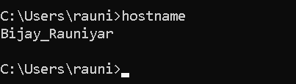

Fig: HOSTNAME

**5.NSLOOKUP**

The nslookup (Name Server Lookup) command is a network administration tool used for querying the Domain Name System (DNS) to obtain domain name or IP address mapping or other DNS records.

**Syntax:** nslookup <domainNam**e>**

**Uses:** Used for troubleshooting DNS issues, verifying DNS records, testing DNS configurations, and performing reverse DNS lookups.

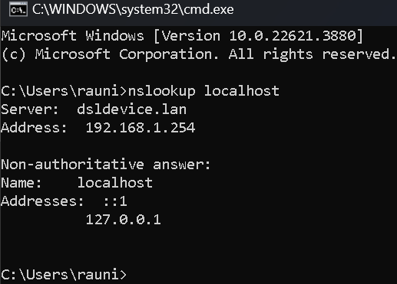

Fig: NSLOOKUP

**6.TRACERT**

Traceroute (Unix/Linux) or tracert (Windows) is a command-line utility used to trace the route that packets take across an IP network to a specified destination, showing each hop and round-trip time (RTT).

**Syntax:** traceroute [OPTION...] HOST

**Uses:** Used to track the pathway taken by packets across an IP network.

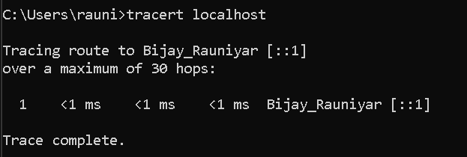

Fig: TRACERT

**7.NETSTAT**

The netstat command is a command-line network utility that shows network connections for TCP (both outgoing and incoming), several network interfaces (software-defined network interface or network interface controller), network protocol statistics, and routing tables.

**Syntax:** netstat

**Uses:** Used for diagnosing network issues and understanding network activity on a system.

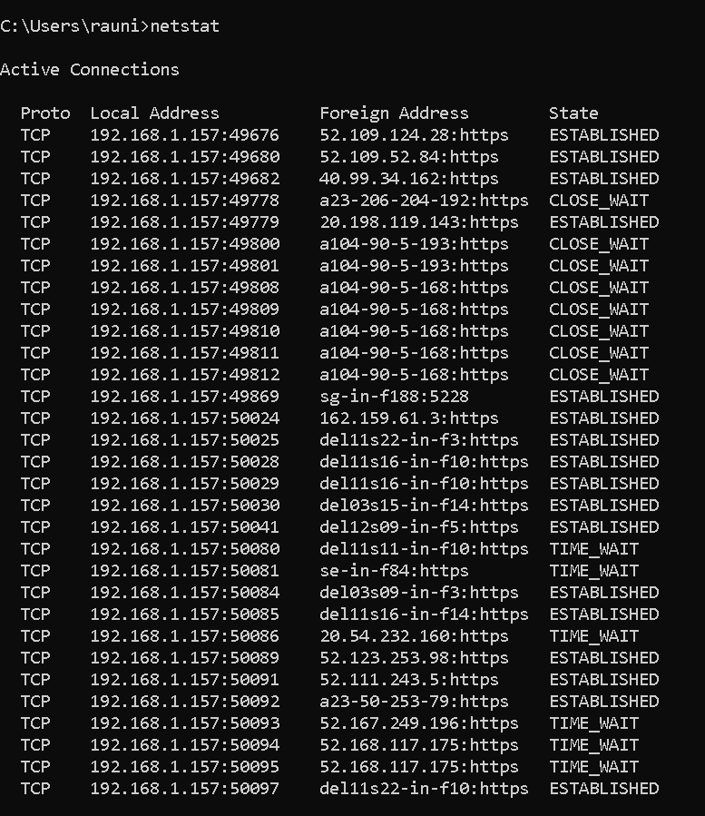

Fig: NETSTAT

**8.ARP**

The ARP commands allows to view, display, or modify the details/information in an ARP table/cache. The ARP cache or table has the dynamic list of IP and MAC addresses of those devices to which our computer has communicated recently in a local network.

**Syntax:** arp

**Uses:** Used to view and manipulate the ARP cache, which maps IP addresses to MAC addresses

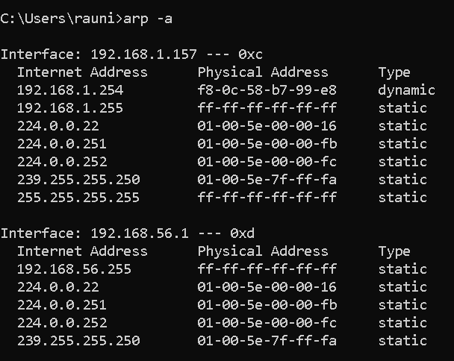

Fig: ARP

**9.SYSTEMINFO**

The Systeminfo command in Windows is a command-line utility that provides detailed information about the system's configuration, including the operating system, hardware, and network settings.

**Syntax:** systeminfo

**Uses:** Used to display detailed configuration information about a computer and its operating system.

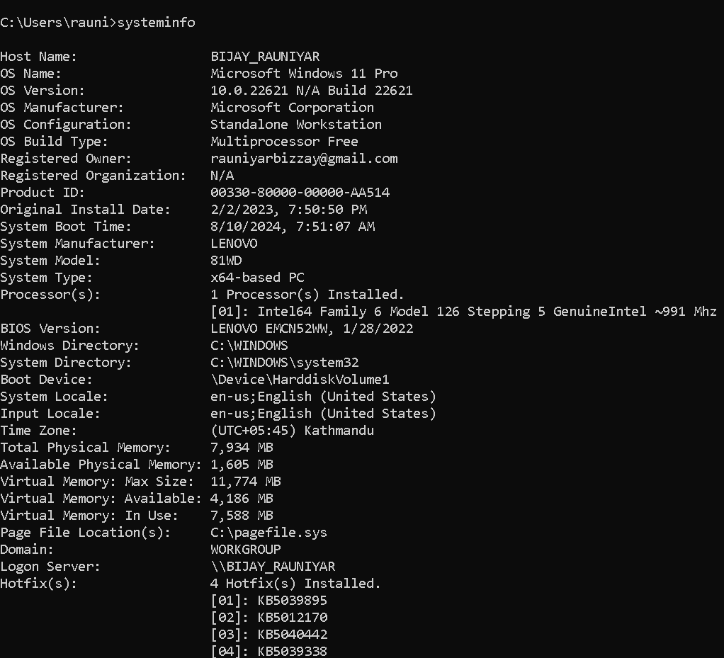

Fig: SYSTEMINFO

**10.PATHPING**

The PATHPING command is a network utility that combines the features of PING and TRACERT. It traces the path to a destination and provides information about packet loss at each hop.

**Syntax:** pathping <destination>

**Uses:** It **c**ombines PING and TRACERT to show path and packet loss information.

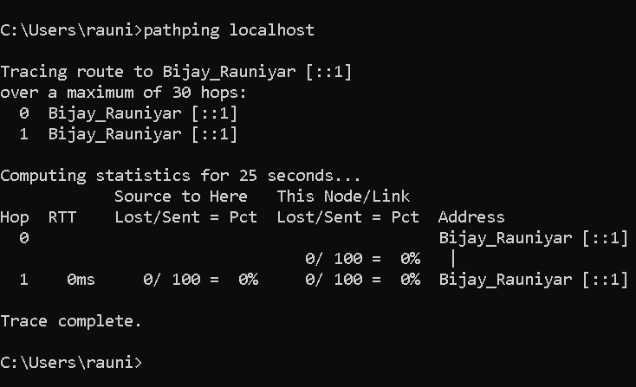

Fig: PATHPING

**Conclusion:**

During the OS installation and practice with basic networking commands, we successfully set up the operating system, ensuring all hardware components were correctly configured and optimized for performance. The process involved using essential commands such as nslookup, tracert, netstat, arp, systeminfo and pathping to troubleshoot and verify network connectivity and system configuration. The outcome was a well-configured system with a clear understanding of network paths, connections, and system details. Through this practice, we learned the importance of these commands in diagnosing and resolving network issues, as well as how to effectively gather detailed system information for maintenance and troubleshooting purposes.